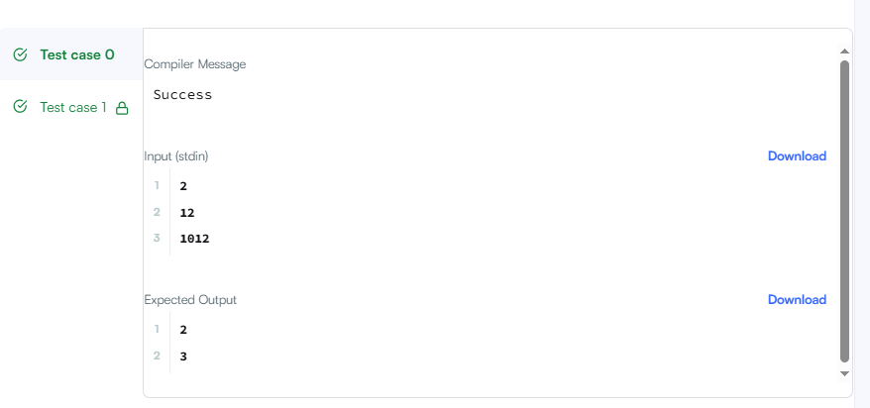
CODE –

#include <stdio.h>

int main() {
int t, n, digit, count;

scanf("%d", &t);

for (int i = 0; i < t; i++) {
scanf("%d", &n);

int temp = n;
count = 0;

while (temp > 0) {
digit = temp % 10;

if (digit != 0 && n % digit == 0) {
count++;
}

temp = temp / 10;
}

printf("%d\n", count);
}

return 0;
}

LINK –
https://www.hackerrank.com/challenges/find-digits/problem

